**Objective**

The objective of this application note is to go over the necessary steps to create a Cscape application that will allow the controller to send e-mail. This can be accomplished by either using the Ethernet port to connect to the internet or using the internal cellular modem, HE-GSM04. The XL6 will be used in this specific example but any of the XL series controllers will be able to perform this operation using the same settings.

**Configuration**

For this example all of the parameters needed to set up a connection will be tied to registers. They do not need to be tied to registers, however having them tied to registers makes them easy to manipulate and adjust without having to re-download the code to the controller. If something is entered incorrectly you can also have it displayed on the screen to make troubleshooting easier.

**For Ethernet Setup:**

1. Go to Controller>Hardware Configuration…

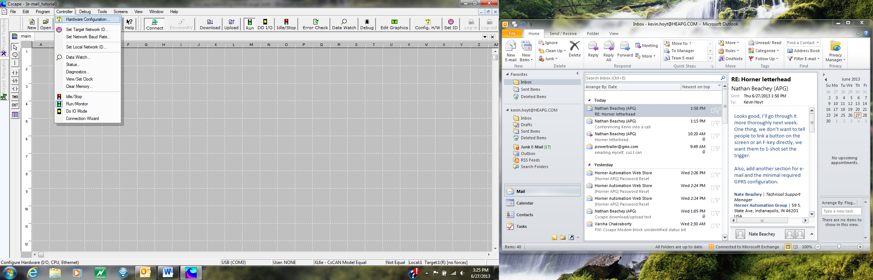

1. From there select the Config button next to the box that says Ethernet

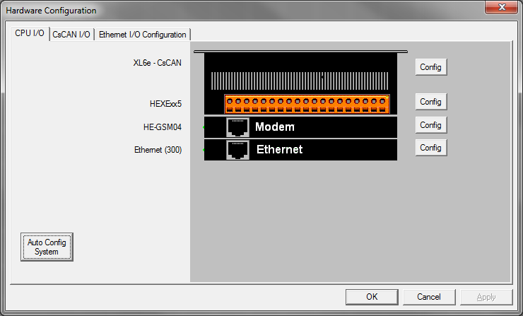

Figure 14 Hardware Configuration Menu

1. From the Configuration Menu go to the Module Setup tab

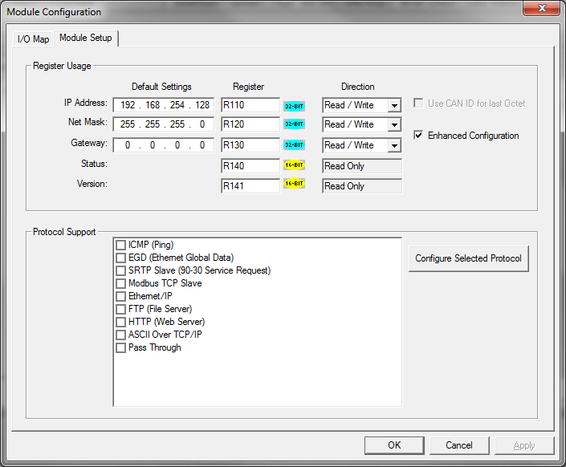

Figure Module Configuration window (for ethernet set up)

1. Either enter in numbers for the IP address, Net Mask, and Gateway or click the Enhanced Configuration check box to enter in registers for each of the numbers (these numbers
   1. If you check the enhanced configuration change the Direction to Read/Write to allow you to make changes in the numbers from the display.
   2. Make note of the 32-bit values because these will need 2 registers each
2. Enter in a register for both the status and the version (these can be used to help trouble shoot if you encounter issues with your Ethernet connection)

**For Cellular Modem (HE-GSM04)**

1. Go to Program>Messaging>GPRS…

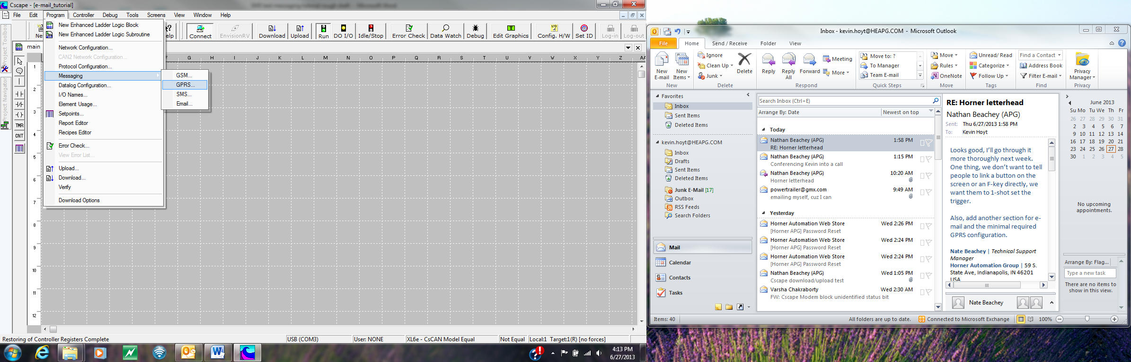

Figure Location of the GPRS Configuration menu

1. Check the box labeled Enable GPRS Configuration

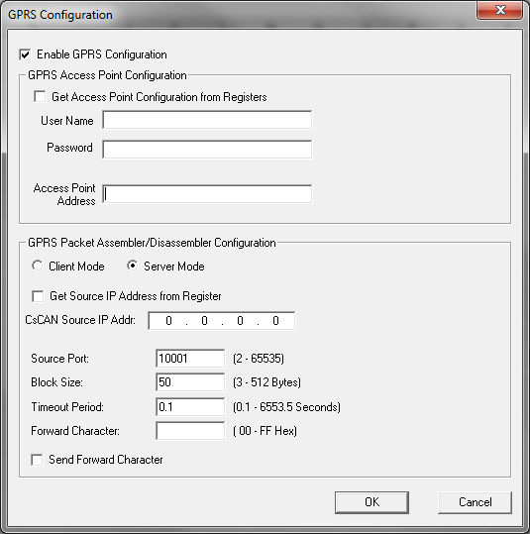

Figure GPRS Configuration Window

1. Enter in a User Name and password if necessary (this information will be different for everyone should be provided from the IT department)
2. Enter in the Access point address (this information will be different for everyone should be provided from the IT department)
3. Everything else can be left at the default values, click OK

**E-mail Configuration**

1. Go to Program>Messaging>Email…

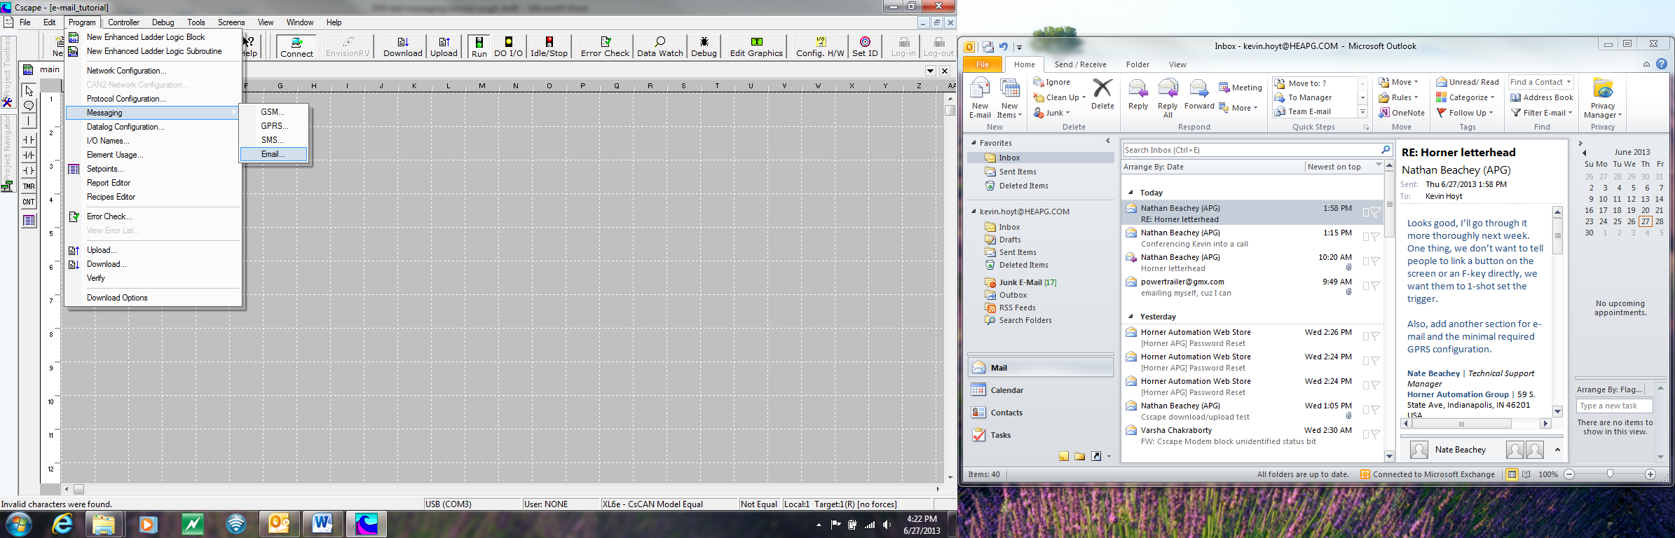

Figure location of the Email Configuration menu

1. Check the box labeled *Enable* *Email Configuration*

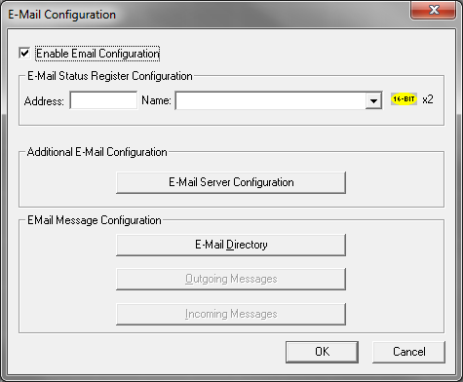

Figure 19 E-Mail Configuration Window

1. Put a register in for the E-mail Status (it takes up two 16 bit registers)
2. Click on the E-mail Server Configuration Button (all of the information on this page will be different for each application and should be obtained from the IT department)

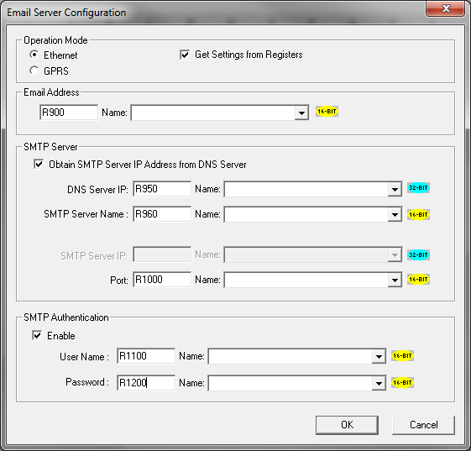

Figure 20 Email Server Configuration

1. Enable either Ethernet or GPRS

**Note: If you are using registers you need keep adequate space between each register, if we allow for 31 characters maximum then all of the inputs except the IP address and the port will take up 16 registers a piece.**

**Our e-mail setup does not support TSL/SSL authentication servers, this prevents us from using many larger e-mail servers such as gmail and yahoo. One e-mail service that we use is gmx.com**

1. If you are using registers check the Get Settings from Registers box as well (again there is a lot of information that goes in here so using registers allows you to make corrections without having to re-load the program as well as view the values from the screen)
2. Enter in the e-mail address to be used to send the e-mails
3. Enter in the DNS Server IP, the SMTP Server Name, the Port
4. Enter the User Name and Password for the SMTP Server
5. Click *OK*
6. Click the Button labeled *E-mail Directory*

**Adding Email Targets to the Directory**

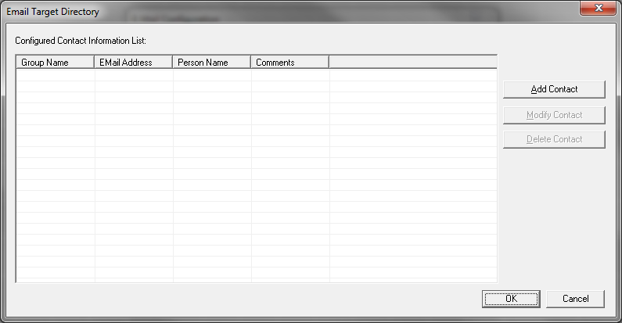

Figure 21 Email Target Directory

1. Click the Button labeled *Add Contact*
2. Fill in a group name for the contact, or select a previously existing group name

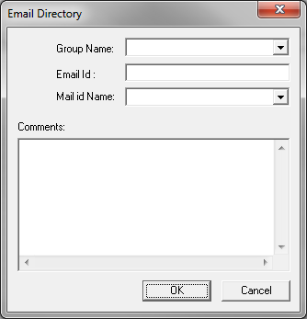

Figure Email Directory

1. Enter the E-mail address to send to in the Email Id: box
2. Enter a name to associate with the above e-mail address in the Mail Id Name
3. Enter any comments to be associated with the above e-mail address (comments appear only in the Email Target Directory)
4. After you have entered in all of the E-mail targets you would like to use click OK until you return to the E-mail Configuration Window

**Creating Email Messages to be sent by the controller**

1. Click on the button that says Outgoing Messages (this button will be greyed out unless you have created at least one E-mail Target)
2. Click on the *Add New Message* button, this is where you will create any messages that you would like to send out

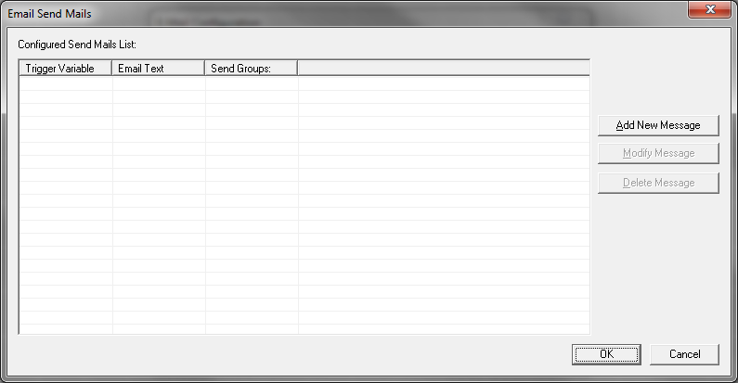

Figure Email Send Mails

1. Assign a 1-bit address to the Trigger variable (when this bit is set high it will send the e-mail associated with it and then reset itself)

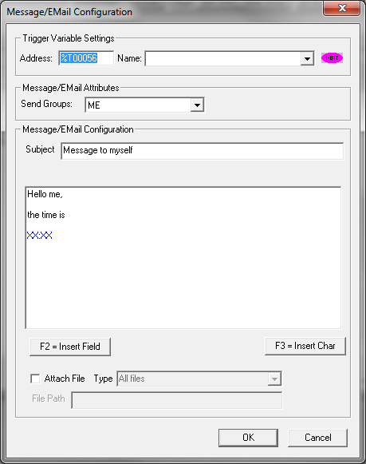

Figure 24 Message/EMail Configuration Window

1. Select the group that you want to send the E-mail to
2. Enter in a subject as well as a whatever you would like to send in the body of the message
3. In order to have a register value added to the message either hit F2 or press the *F2 = Insert Field* button

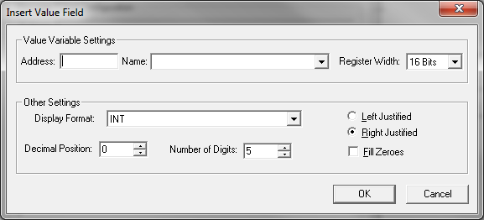

Figure Insert Value Field (into the body of the email) window

1. Enter in the register that you wish to have displayed as well as the register width
2. Select the Display format, the decimal position, and the number of digits you would like to display (again as with the text messages the number of characters the number takes up is pre-determined, select Fill zeros to fill any unused digits with zeros)
3. If you would like to have the controller attach a file check the Attach file box, from there you can select one of many options for which file to attach, for each selection you will need to specify the drive for it to attach files from, “A:\” for micro SD or Compact Flash, “B:\” , if no drive is specified it will default to “A:\”
   1. **All files**: will attach all the files on the specified drive to the e-mail
   2. **Latest file:** will attach the most recently created file from the drive to the e-mail
   3. **Oldest file:** will attach the oldest file from the drive to the e-mail
   4. **One previous to latest file:** will attach the second most recently created file from the drive to the e-mail
   5. **Specified file (select filename):** will attach a file specified by a file path that you enter into the file path box (it will either need to start with “A:\” or “B:\”
4. After the message has been configured hit *OK* until you return to the main Cscape screen

**Example code to show how to send e-mails in ladder logic**

Now that the e-mail has been configured here is some example code to send the first e-mail

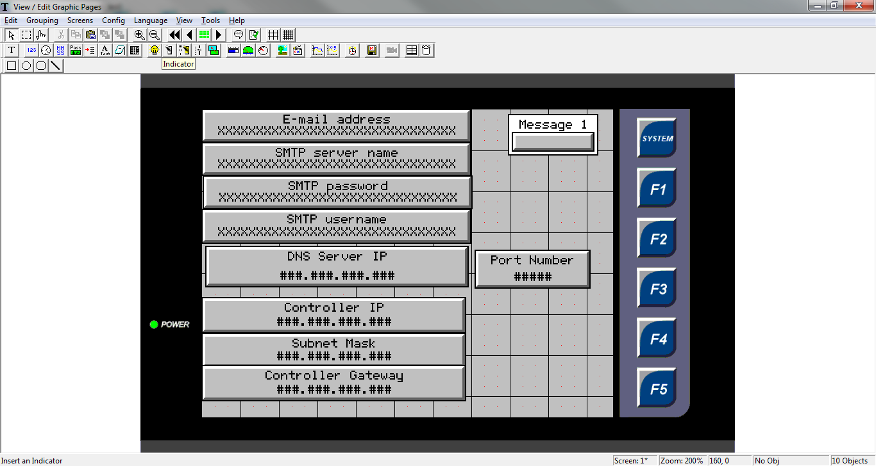

This button is the only thing you need if you did not make all of the other variables registers

Figure 26 Example code graphic configuration

* There is a lot on this screen, but it is all ASCII data or numeric data to fill in the registers that were assigned during the configuration
* If you are using the add on modem there are several of these boxes that you don’t need (IP address, Subnet Mask, and Controller Gateway)
* All of the data fields can either be entered in manually or set at the beginning, the data fields on the screen are for the ability to change the settings without having to reload the controller
* In the upper right hand corner the button is set up so that once it is pressed it will use the ladder logic to set the email send trigger

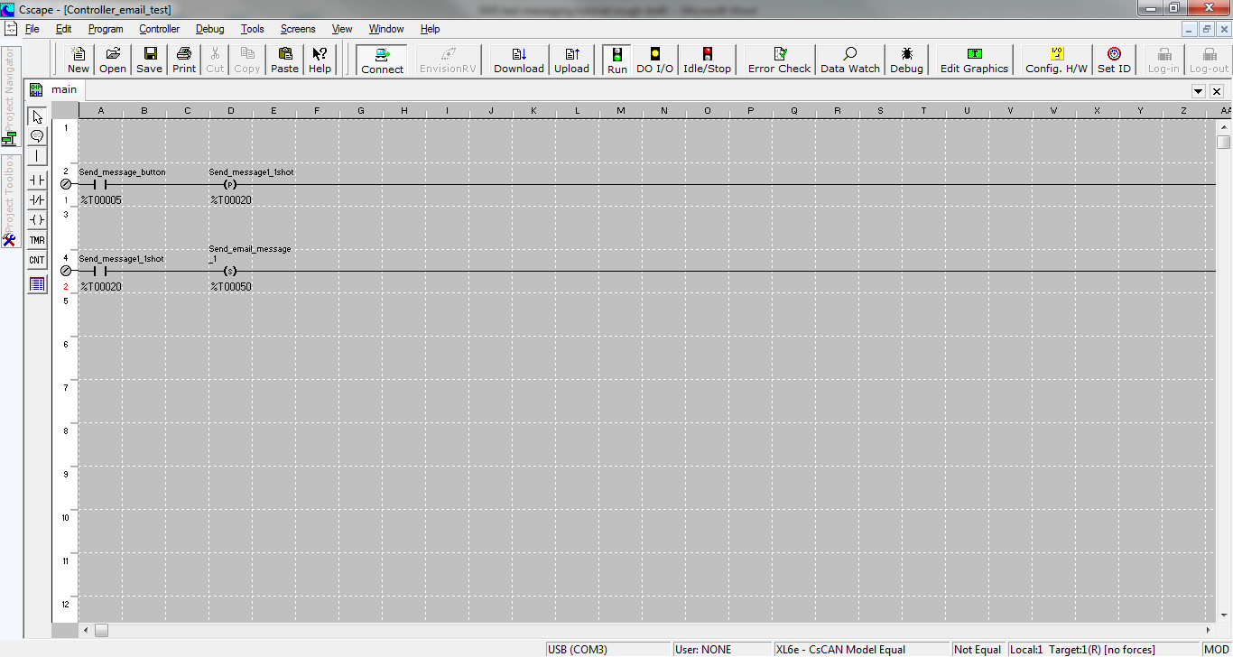

Figure 27 Example code ladder logic configuration

* Rung 1 of the ladder logic has the contact linked to the button activating a positive transition coil (this way if the button is held down the unit will not send multiple e-mails)
* Rung 2 has the a contact linked to the positive coil going to a set coil that is linked to the trigger variable for the e-mail (if more than one e-mail message is activated on the same rung they will be sent in the order they appear in on the *Email Send Mails* window from the configuration)

The email can be set up to send multiple emails under different scenarios. With the use of counters you can set it up to send an email periodically, or you can set the trigger bit to activate when an alarm or warning goes off.